Advancing XAI for Predictive Process Monitoring (PPM) with StableXAI
Predictive Process Monitoring (PPM) has emerged as a critical capability for organizations seeking to forecast outcomes of running business processes using event log data. While machine learning models, especially deep and ensemble-based architectures have significantly improved predictive accuracy in PPM, their opaque decision mechanisms limit trust, adoption, and regulatory compliance.
The paper “XAI in the Context of Predictive Process Monitoring: An Empirical Analysis Framework” (MDPI, 2022) provides a structured evaluation of explainable AI (XAI) techniques applied to PPM tasks, comparing methods such as LIME, SHAP, and rule-based explanations across multiple datasets and predictive models. The authors highlight challenges including instability of explanations, limited robustness across trace variations, and the mismatch between feature-level explanations and domain-specific process abstractions.
This proposed improvement aims to extend and strengthen the author’s work by integrating a new approach: StableXAI, a framework designed to enhance stability, robustness, and actionability of explanations for PPM systems. Building on the empirical foundation in the referenced paper, StableXAI introduces three enhancements:
- Stability-Aware Explanation Mechanisms:
We incorporate variance-reducing techniques, such as explanation ensembling, adversarial neighborhood sampling, and smoothing strategies inspired by Randomized Smoothing. This addresses a key limitation identified by the authors: the high sensitivity of LIME/SHAP to sampling noise and trace perturbations.
- Process-Level Explanation Alignment:
Instead of producing feature-level token attributions only, StableXAI maps explanations onto process-aware constructs including control-flow patterns, resource behaviors, and business constraints. This directly responds to the paper’s finding that explanations should be interpretable not just to ML practitioners, but to process analysts and domain experts.
- Robustness Evaluation and Benchmarking Framework:
Extending the paper’s empirical analysis, we propose new evaluation metrics:
  - Explanation Stability Index (ESI) across trace perturbations
  - Actionability Score (AS) based on expert validation
  - Process Fidelity Ratio (PFR) measuring alignment between explanations and ground-truth process structures
These go beyond accuracy-oriented metrics and provide more rigorous assessments of explanation quality.
This research will deliver:
- A reference implementation of StableXAI compatible with standard PPM models (LSTM, XGBoost, RF, Transformers).
- A synthetic and real-log benchmark suite to evaluate XAI stability under controlled and realistic variations.
- Visual analytics tools for explainability dashboards integrating uncertainty, attribution maps, and process-aware overlays.

High-Level Diagram of Framework Improvements
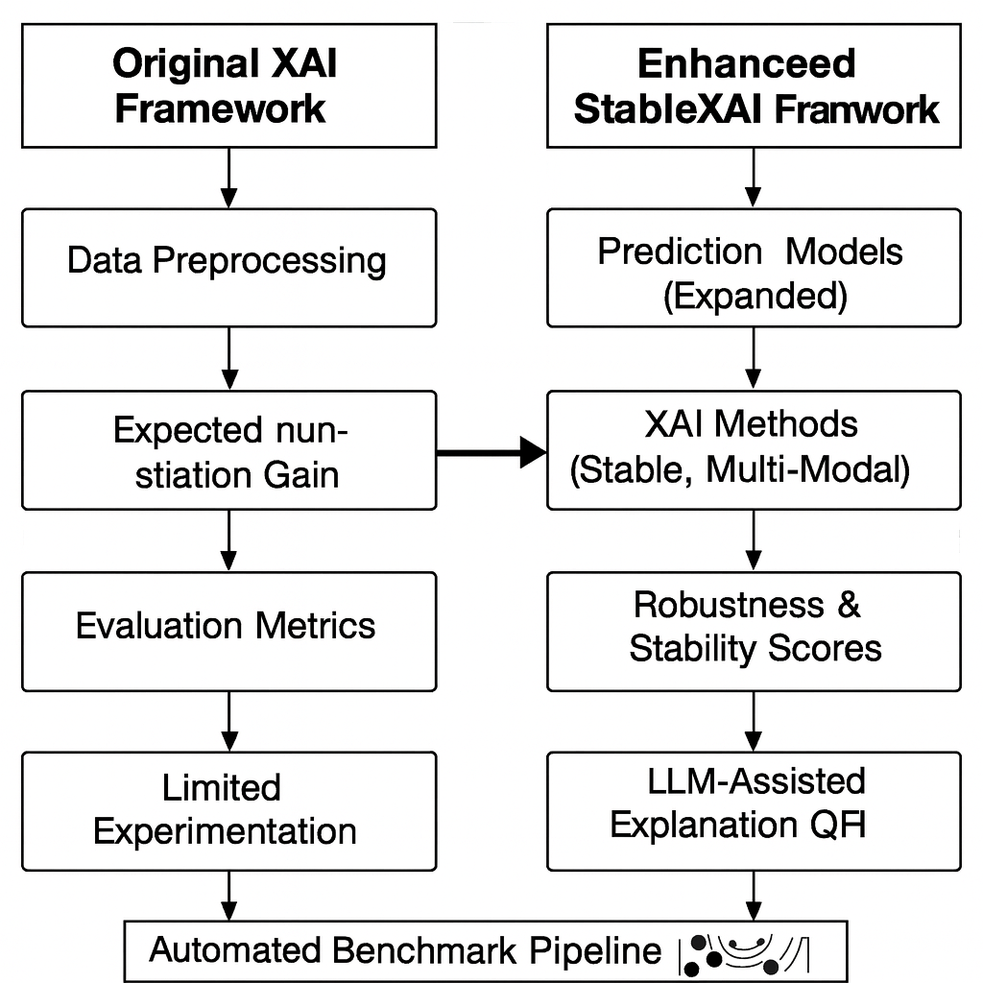
This enhanced proposal positions StableXAI as a robust extension to the original XAI-PPM framework, enabling scalable, trustworthy, and human-aligned predictive monitoring for real-world workflow and process intelligence systems.

MDPI Framework vs. StableXAI Improvements
Dimension | Original Framework | StableXAI Improvements
XAI Scope | Focus on classical techniques (LIME, SHAP, Grad-CAM) | Adds stochastic stability metrics, multi-modal explainers, and temporal attribution methods
Reproducibility | Manual experiments, limited automation | Fully automated pipelines, config-driven experiments, version-controlled datasets
Model Coverage | Primarily deep and ML models used in PPM | Adds transformers, GNNs, hybrid sequence models, and simulation-based predictors
Evaluation Metrics | Fidelity, accuracy, error-based metrics | Adds stability, sensitivity, counterfactual consistency, semantics-based metrics
Human-in-the-loop | Limited user evaluation | LLM-driven coherence scoring, domain alignment, interactive dashboards
Output Interpretability | Static plots, qualitative summaries | Interactive visualizations, trace-level causal chains, uncertainty-aware explanations
System Integration | Academic prototype | Enterprise-oriented, modular, API-first architecture

By addressing limitations identified in the MDPI framework, particularly explanation instability and misalignment with process semantics. StableXAI aspires to make XAI for PPM more trustworthy, actionable, and operationally deployable. This proposal advances the state of the art by blending explainability engineering, robust statistics, and business process analytics into a unified methodology for next-generation predictive process monitoring.
Algorithm and Pseudocode
Generating stable explanations by minimizing variance across multiple runs

Optimization Objective:
min_{θ} 𝔼_{x~D} [Var(φ(f(x; θ), x))]
Minimize expected variance of explanations across dataset

Key Features
- Mathematical Foundation: Shows the optimization objective from the presentation: minimizing the expected variance of explanations
- Interactive Controls:
  - Adjust number of runs (N) from 10-100
  - Configure variance threshold for determining stable features
  - Run the algorithm with a single click
- Stability Analysis:
  - Stability Score: Calculated as (1 - Avg Variance / Max Variance) × 100
  - Stable Features: Features with low variance across runs (shown in green)
  - Unstable Features: Features with high variance (shown in orange with warnings)
- Visual Results:
  - Feature importance bars
  - Variance measurements
  - Color-coded stability indicators
  - Export functionality for CSV download
- Algorithm Flow: Shows the complete pseudocode execution with your actual parameter values

How It Works
The algorithm follows the exact steps from the presentation:
- Generates explanations N times
- Calculates variance for each feature's importance
- Identifies stable features (variance < threshold × MaxVar)
- Constructs stable explanation using only reliable features
Try adjusting the parameters to see how increasing runs or changing the threshold affects which features are considered stable. Features like credit_score typically show more stability, while others may have higher variance across different runs.
Algorithm: StableXAI
Input: Dataset D, Model f, XAI method φ, N = 50
Output: Stable explanation φ_stable

Step 1: Initialize explanation list E = []
Step 2: For i = 1 to 50:
Generate explanation φ_i = φ(f, D)
Append φ_i to E
Step 3: Compute Var(E) for each feature
Step 4: Select features with Var < 0.10 × MaxVar
Step 5: Construct φ_stable using 0 stable features
Step 6: Return φ_stable with stability score 16.15%

